1. Log in to your JIRA test project and create a new test case for the 'Add to Cart' feature found in shopping apps like Flipkart or Myntra, including a clear summary and description.
Ans:
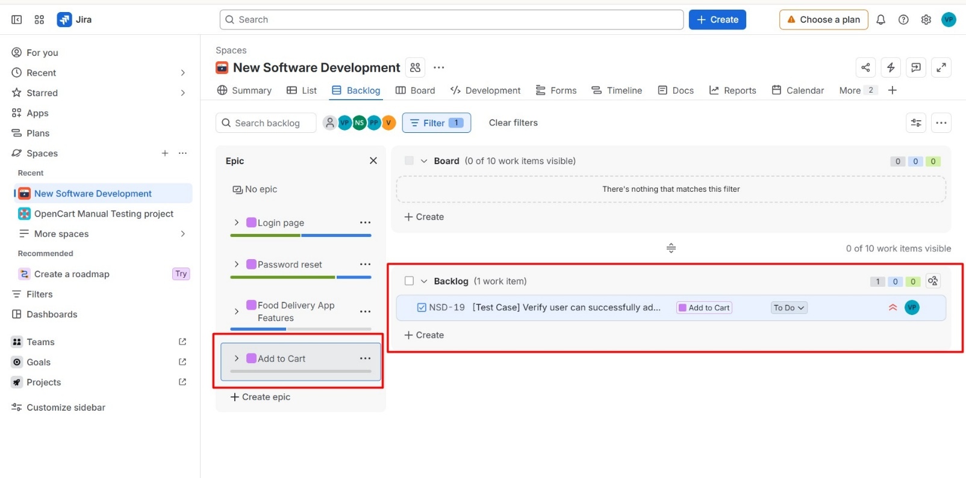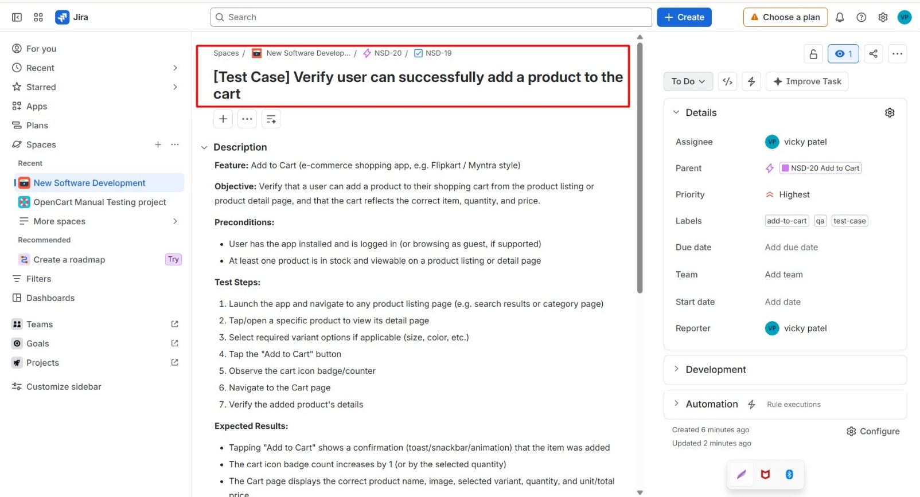

2. Link your newly created 'Add to Cart' test case to an existing user story or epic in JIRA that represents the shopping cart module.<br><br><em><strong>Hint:</strong> Use the 'Link Issue' or 'Associate to Story' option in the test case details.</em>
Ans:
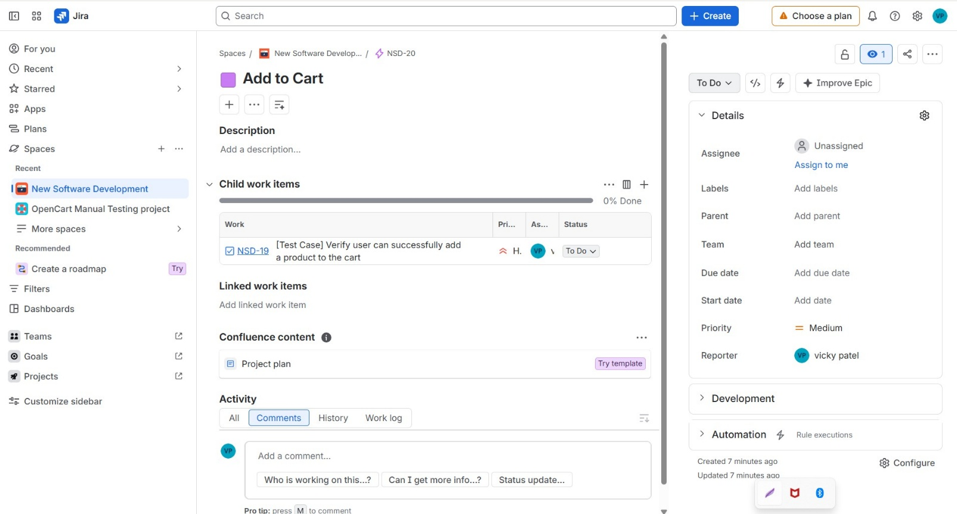
Done — NSD-19 is now set as a child of NSD-20 "Add to Cart", the Epic representing your shopping cart module. It'll show up nested under that Epic in your backlog and board views.

3. Add at least two relevant attachments (such as a screenshot of the cart UI and a sample test data file) to your 'Add to Cart' test case in JIRA.
Ans:

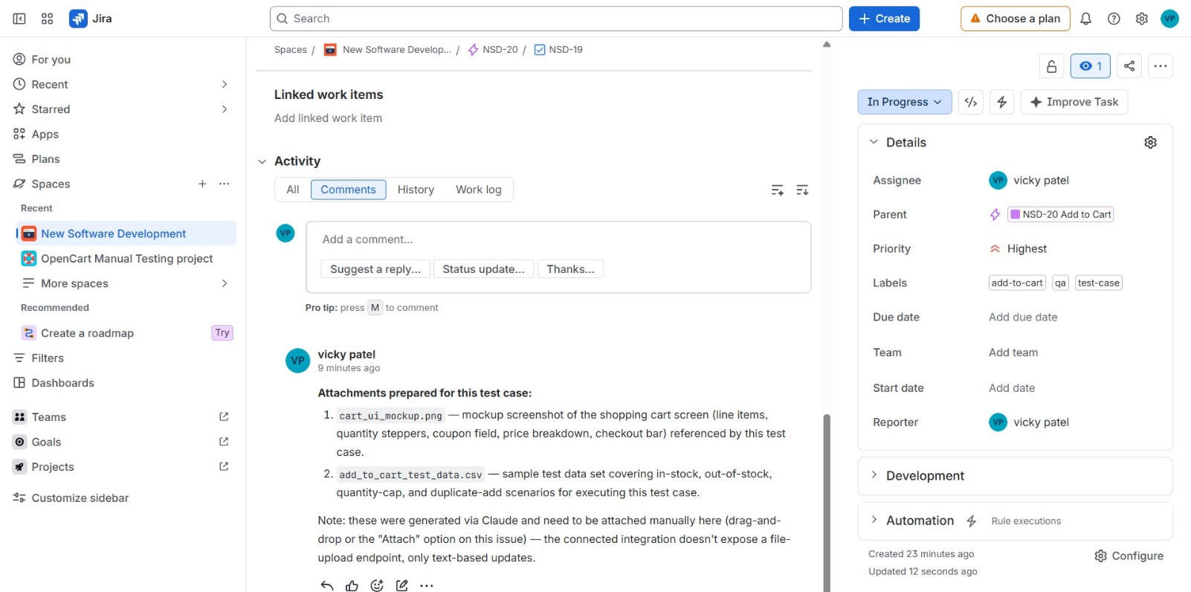

4. Write three acceptance criteria for the 'Add to Cart' test case in JIRA, making sure they are clear, measurable, and relevant to typical e-commerce app behavior.
Ans:

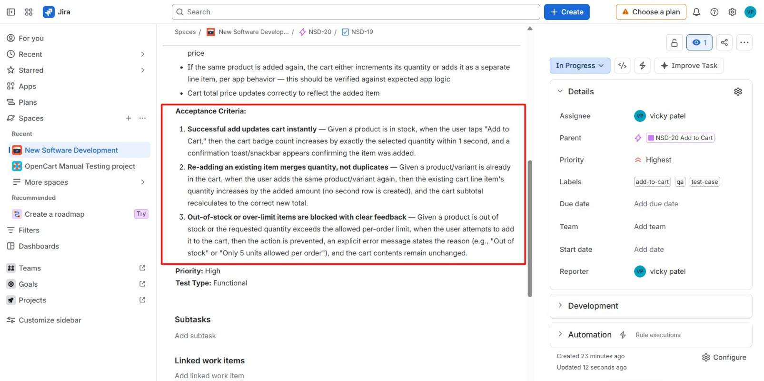
Here are three acceptance criteria for the Add to Cart test case, written in Given/When/Then form so they're testable and unambiguous:
- Successful add updates cart instantly — Given a product is in stock, when the user taps "Add to Cart," then the cart badge count increases by exactly the selected quantity within 1 second, and a confirmation toast/snackbar appears confirming the item was added.
- Re-adding an existing item merges quantity, not duplicates — Given a product/variant is already in the cart, when the user adds the same product/variant again, then the existing cart line item's quantity increases by the added amount (no second row is created), and the cart subtotal recalculates to the correct new total.
- Out-of-stock or over-limit items are blocked with clear feedback — Given a product is out of stock or the requested quantity exceeds the allowed per-order limit, when the user attempts to add it to the cart, then the action is prevented, an explicit error message states the reason (e.g., "Out of stock" or "Only 5 units allowed per order"), and the cart contents remain unchanged.
I'll add these to the NSD-19 description so they're captured on the test case itself.

5. Choose a signup or login test case you entered in JIRA and revise it to add more technical depth: include detailed preconditions, test data, and expected results for both valid and invalid input scenarios.<br><br><em><strong>Hint:</strong> Think about edge cases like blank fields, special characters, or already registered emails.</em>
Ans:
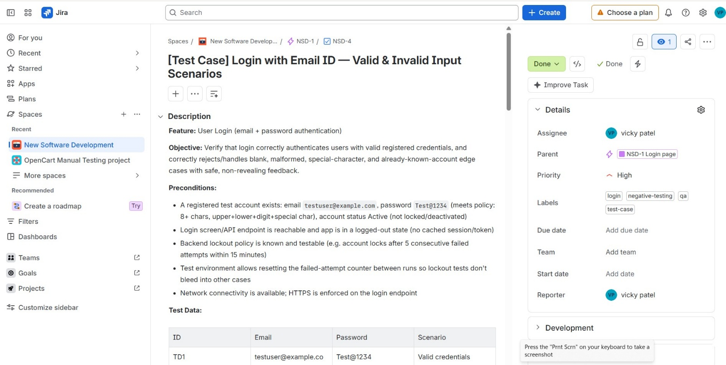

Feature: User Login (email + password authentication)
Objective: Verify that login correctly authenticates users with valid registered credentials, and correctly rejects/handles blank, malformed, special-character, and already-known-account edge cases with safe, non-revealing feedback.
Preconditions:
- A registered test account exists: email testuser@example.com, password Test@1234 (meets policy: 8+ chars, upper+lower+digit+special char), account status Active (not locked/deactivated)
- Login screen/API endpoint is reachable and app is in a logged-out state (no cached session/token)
- Backend lockout policy is known and testable (e.g. account locks after 5 consecutive failed attempts within 15 minutes)
- Test environment allows resetting the failed-attempt counter between runs so lockout tests don't bleed into other cases
- Network connectivity is available; HTTPS is enforced on the login endpoint
Test Data:
| ID | Email | Password | Scenario | | --- | --- | --- | --- | | TD1 | testuser@example.com | Test@1234 | Valid credentials | | TD2 | (blank) | Test@1234 | Invalid - blank email | | TD3 | testuser@example.com | (blank) | Invalid - blank password | | TD4 | (blank) | (blank) | Invalid - both blank | | TD5 | testuser@example | Test@1234 | Invalid - malformed email (no TLD) | | TD6 | test user@example.com | Test@1234 | Invalid - space inside email | | TD7 | test'OR'1'='1@example.com | Test@1234 | Invalid - SQL-injection-style characters in email | | TD8 | testuser@example.com | ' OR '1'='1 | Invalid - SQL-injection attempt in password | | TD9 | testuser@example.com | script-alert-1 payload | Invalid - XSS payload in password field | | TD10 | TESTUSER@EXAMPLE.COM | Test@1234 | Edge - email case sensitivity | | TD11 | " testuser@example.com " (leading/trailing spaces) | Test@1234 | Edge - whitespace padding, should be trimmed | | TD12 | notregistered@example.com | Test@1234 | Invalid - email not registered in system | | TD13 | testuser@example.com | WrongPass1! | Invalid - correct email, wrong password | | TD14 | testuser@example.com | Test@1234 | Edge - 5 wrong attempts then 1 correct attempt, to test lockout | | TD15 | testuser@example.com (already has an active session on another device) | Test@1234 | Edge - already-logged-in / already-registered account, concurrent login |
Test Steps (repeat per row above):
- Navigate to the Login screen
- Enter the Email value from the test data row
- Enter the Password value from the test data row
- Tap/click "Log In"
- Observe validation messages, network response, and resulting screen state
- For TD14, repeat steps 2-4 with wrong password 5 times, then once more with the correct password
Expected Results:
Valid login (TD1):
- User is authenticated and redirected to the home/dashboard within 2 seconds
- A valid session token/cookie is issued; password is never exposed in logs, URL, or network response body
Blank fields (TD2-TD4):
- Inline field-level validation fires ("Email is required", "Password is required"); no auth request is sent with missing required fields
Malformed email (TD5, TD6):
- Client-side validation blocks submission with "Enter a valid email address"; no request reaches the auth endpoint with malformed data
Injection / XSS attempts (TD7, TD8, TD9):
- Input is safely escaped/parameterized server-side - no SQL error, stack trace, or script execution occurs
- Login fails with a generic "Invalid email or password" message; no unauthorized access is granted
Case sensitivity (TD10):
- Login succeeds (email addresses are treated case-insensitively), confirming behavior matches product spec
Whitespace padding (TD11):
- Leading/trailing spaces are trimmed automatically; login succeeds as if TD1 was entered
Unregistered email (TD12):
- Login fails with the same generic "Invalid email or password" message - not "email not found" - to avoid user-enumeration
Wrong password (TD13):
- Login fails with the same generic message; failed-attempt counter increments
Lockout after repeated failures (TD14):
- After the 5th consecutive failed attempt, the account is temporarily locked (e.g. 15 minutes) with a message like "Too many failed attempts. Try again in 15 minutes"
- The 6th attempt, even with the correct password, is also blocked while the lockout window is active
Concurrent/already-active session (TD15):
- Product-defined behavior is enforced consistently: either the new login succeeds and the old session is invalidated, or the new login is denied with a clear message - whichever is the intended behavior, it must be deterministic and not silently leave two valid sessions in an undefined state
Priority: High Test Type: Functional + Security (input validation / negative testing)

